[CSO letterhead / organization name]
[Date]

To: Name, Title
[Chair and Members of the Country Coordinating Mechanism (CCM)]

Cc: Name, Title
[National TB Programme, National Laboratory, Ministry of Health, Global Fund Principal Recipient(s), Technical Working Group members]

Date 2026

Subject: Inclusion of near point-of-care TB tests in [Country] GC8 funding request to close the deadly diagnostic gap

Dear CCM Chair and Members,

We are writing on behalf of [organization name or the undersigned organizations] to urge the CCM to ensure that near point-of-care (NPOC) tuberculosis (TB) tests are included in the country’s Global Fund Grant Cycle 8 (GC8) funding request. TB diagnosis remains a major gap in the TB response, and many people still face delayed diagnosis because testing is too far away, too slow, too expensive, or too difficult to access. [Insert sentence that incorporates national data that demonstrate gaps in TB testing and diagnosis, e.g., % of people diagnosed with molecular tests, continued reliance on smear microscopy, etc.]. NPOC tests offer a timely opportunity to bring accurate TB diagnosis closer to people who need it most, while also supporting more equitable and sustainable TB service delivery.

The timing is critical. The WHO recommended NPOC TB tests in March 2026 and the Global Fund is incentivizing NPOCs adoption in GC8. This is the first major TB diagnostic innovation since GeneXpert. CCMs have a critical role to play in shaping how this innovation is introduced. Country programs should seize this moment to secure both Global Fund and domestic financing for NPOC introduction and scale-up to expand access to rapid molecular testing in peripheral laboratories, health clinics, mobile units, and community-based service delivery points that currently lack laboratory capacity.

The evidence supporting NPOC adoption is compelling. NPOC tests are affordable and accurate molecular tools, with performance comparable to commonly used molecular tests and far superior to smear microscopy. The WHO recommends NPOC tests as the initial diagnostic test for adults and adolescents with presumptive pulmonary TB, replacing smear microscopy, with tongue swabs available as an option when sputum cannot be collected. The first available NPOC test, PlusLife MiniDock MTB, showed a sensitivity of 85.7% and specificity of 97.6% on sputum swabs, and a sensitivity of 79.6% and specificity of 99.5% on tongue swabs. By comparison, Xpert MTB/RIF Ultra has reported sensitivity of 90% and specificity of 96% using sputum samples. The PlusLife MiniDock MTB test can detect TB in under 30 minutes, is available for procurement through the Global Drug Facility catalog at US$3.60 per test, and requires the portable PlusLife MiniDock Ultra device and thermolyse machine, priced at US$155 and US$180, respectively.

The current evidence suggests three broad use-cases for NPOC tests, although countries can select other more targeted use cases most appropriate for their contexts. The three strategic ways NPOC tests can be used are for:

- Cost containment at existing molecular sites, by using NPOC tests to increase testing volume while reserving more expensive molecular platforms for reflex drug susceptibility testing.
- Improved access to quality diagnostics at microscopy and treatment sites, by replacing smear microscopy with molecular testing and improving diagnostic quality and speed.
- Expanded access at primary health care and other sites without TB diagnostic infrastructure, by bringing molecular testing closer to communities.

We therefore ask the CCM to include a clear NPOC introduction strategy with ambitious, costed targets in the GC8 funding request. [COUNTRY] should adopt a bold rollout plan and develop a roadmap with phased targets for the GC8 period, aligned with the national strategic plan and implementation readiness. [COUNTRY] should prioritize [insert use case that can target country-specific diagnostic gaps, eg: replacing smear microscopy, expanding TB testing to primary health care sites, prioritising high-volume TB treatment sites]. We encourage adoption of ambitious, phased targets towards the goal of 100% of people with presumptive TB tested with a WHO-recommended rapid diagnostic test (WRD), as well as 100% facility coverage through an on-site WRD or specimen referral system by 2030. We therefore encourage the CCM to reflect this approach in the funding request and to define ambitious, feasible targets for the selected use cases and rollout timeline.

Table 1: Example of an ambitious five-year roadmap
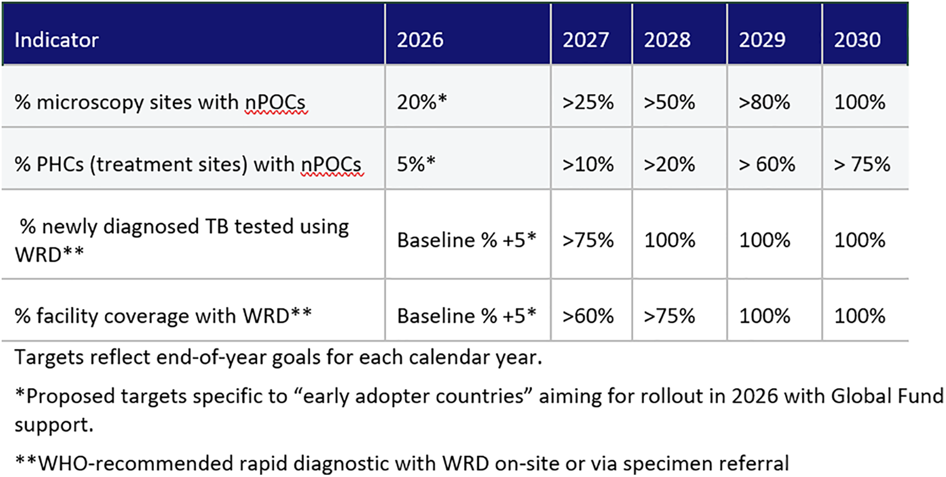

The funding request should include the full implementation package needed to maximize the impact of NPOCs on closing gaps in the cascade of care. This includes budget lines for the five S’s: staff, stuff, space, systems, and support. In practical terms, this means funding for devices, tests, updating diagnostic algorithms and relevant policies, training, supervision, sample transport for reflex drug susceptibility testing, connectivity, maintenance, community engagement, and all other operational requirements needed to implement updated WHO guidance. The Global Laboratory Initiative’s implementation toolkit for NPOC-NAAT and swab-based TB testing provides practical and adaptable resources, and we urge you to utilize this resource to ensure implementation planning is aligned with the updated guidelines.

Finally, communities should be central to NPOC introduction and rollout. Community and civil society actors can help identify priority sites, overcome barriers to testing such as stigma, distance, and clinic hours, link people to care and support, and provide feedback necessary to ensure NPOCs are improving access in practice. We strongly encourage the CCM and National TB Program to involve communities in site prioritization, implementation, and monitoring and evaluation mechanisms throughout the grant cycle.

We thank you for considering this request and stand ready to work with the CCM, National TB Program, and other stakeholders to ensure that NPOC TB tests are included in GC8 and help transform TB diagnosis by expanding timely, equitable access to rapid molecular testing for people who need it most.

Sincerely,
[Name]
[Title]
[Organization]
[Contact information]

On behalf of:
[ORGANIZATIONS IN FORMATION]

Resources:

- Treatment Action Group. Near Point-of-Care TB Tests: What Communities Need to Know. Fact Sheet. New York: TAG; April 2026. Available at: https://www.treatmentactiongroup.org/publication/npoc-factsheet/
- Claudia M. Denkinger, Seda Yerlikaya, Adithya Cattamanchi, Madhukar Pai, Near point-of-care molecular tests for tuberculosis: what will it take to realize their potential? eClinicalMedicine, Volume 95, 2026, 103972, ISSN 2589-5370, https://doi.org/10.1016/j.eclinm.2026.103972.
- “Why Countries Must Move Boldly on Near Point-of-Care TB Diagnostics.” PLOS Global Public Health. March 2026. Available at: https://journals.plos.org/globalpublichealth/article?id=10.1371/journal.pgph.0006134
- World Health Organization (WHO). Near Point-of-Care Tests, Tongue Swabs, and Sputum Pooling for TB. Geneva: WHO Global TB Programme; 2026. Available at: https://www.who.int/teams/global-programme-on-tuberculosis-and-lung-health/ diagnosis-treatment/npoc-tongue-swabs-and-sputum-pooling-for-tb
- Médecins Sans Frontières (MSF). Near Point-of-Care Tests for Tuberculosis: What You Need to Know. Fact Sheet. Paris: MSF; February 2026. Available at: https://www.msf.org/report-near-point-care-tests-tuberculosis.
- SamiNAPP. MiniDock Cost Comparison Tool: Cost Analysis for Presumptive TB Testing Using LCaNAAT and NPOC Molecular Tests. Online tool. Available at: https://saminap.shinyapps.io/minidock/
- Diagnostics Equity Consortium. New Near Point of Care TB Tests. March 2026. Available at: https://tinyurl.com/nPOCs
- Treatment Action Group. An Activist’s Guide to Diagnostic Tools for Tuberculosis 2025. New York: TAG; April 2026. Available at: https://www.treatmentactiongroup.org/publication/an-activists-guide-to-diagnostic-tools-for-tuberculosis-2025/
- Stop TB Partnership Global Laboratory Initiative. GLI's NPOC and Swab-Based Testing Toolkit. Available at: https://www.stoptb.org/who-we-are/stop-tb-working-groups/global-laboratory-initiative-gli/gli-guidance-and-tools/tb-near-point-care-and-swab-based-testing-toolkit

“Why Countries Must Move Boldly on Near Point-of-Care TB Diagnostics.” PLOS Global Public Health. March 2026. Available at: https://journals.plos.org/globalpublichealth/article?id=10.1371/journal.pgph.0006134

